GM User Documentation

Last Updated: 11/13/2021

Contents

Licensing 2

Introduction 2

Design Assumptions For This Framework 2

Number One Rule For Using This Framework 3

Why Use MapTool 3

Advanced Topic: lib:elevation Will Make You Fly (Strongly Recommended) 4

Major Framework Components 5

Campaign Properties 5

Basic 5

Hero Lab POR File 5

TokenLibCampaignData 5

TokenLibCharacterSheet 5

TokenLibCharacterSheetData 5

TokenLibConfiguration 5

TokenLibUtilities 5

Library Tokens 5

Image Tables 6

Campaign Macros 6

GM Macros 6

Windows Used For Macros By This Framework 6

Campaign Window 6

GM Window 6

Selection Window 6

Recommended Optional Additions To This Framework 7

MapTool Help, Add Default Tables 7

lib:frames 7

Upgrading To Newer Version Of My Framework 9

Upgrading Campaign Settings 9

Upgrading The Library Tokens 9

How The Upgrade Process Works 9

Settings To Use To Start The MapTool Server 9

Hero Lab® Import And Synchronization 10

How To Do The Initial Hero Lab® Import 10

Add Resource to Library 10

Drag Hero Lab® POR File Token To Map 11

Run GM Macro “Sync Token With Hero Lab® POR File” 12

GM Macro “Optimize Token Data For Game Play” 16

Consider Doing It All In One Step With “Sync & Optimize Token With Hero Lab® POR File” 16

Synchronize Token With Hero Lab® POR File 16

Do A Bunch Of Tokens At Once 17

What’s Not Done Yet 17

Overview Of Important Features And Concepts 17

Token Ownership 17

Stat Sheet 18

Campaign Window 18

Color Coded Buttons 18

“Copy” Buttons 19

“Give Item” Button 19

“Change Elevation” Button 19

“Campaign” Buttons 20

“Log” Buttons 20

“Adjustments, Permanent & Temporary” Buttons 20

“Edit Spells Prepared” Button 20

“Validate Spell Limits” Button 21

“Set Item Locations” Button 21

“Rollup” Button 21

GM Window 21

Macros 22

# Licensing

In terms of licensing, this document is part of the “Software” located on [GitHub](https://github.com/adventuremagic123/PF1e-And-3.5-Framework-For-MapTool) and is covered by the [license](https://github.com/adventuremagic123/PF1e-And-3.5-Framework-For-MapTool/blob/main/License.html).

# Introduction

The goal for this document is to help GMs understand how to use my framework. This is a document that is very much in progress. I will continue updating it as I have time.

# Design Assumptions For This Framework

The design assumptions for this framework are as follows. Understanding them will make it easier for you to learn the framework.

1. Only a minimal number of rules would be automated.
2. All decisions would be made and enforced by the GM.
3. An audit log was needed because GMs and Players forget.
4. Campaign management was needed because GMs need help.
5. Many rules depend on context too complex to be automated.
6. GMs and Players may only be interested in using some features but not others.
7. When features are not desired to be used, just like on a character sheet, they are simply not filled in.
8. A detailed breakdown of all the modifiers for attacks is desired to help ensure valid game play.
9. To avoid trying to support all the feats, class abilities, spells, etc., attacks would be copied, named appropriately, and modified, on the fly if desired.
10. Players like to determine what spells they want to prepare in advance, not when the GM says their characters are resting.
11. Campaigns like to use a wide variety of material, rules, and home rules.
12. Make things intuitive to decrease learning time.
13. Flying, levitation, and other things involving elevation would be needed.
14. Hero Lab(R) is needed especially by GMs to import NPCs into this framework, otherwise it would take too long to enter the data.
15. Being able to synchronize changes from Hero Lab(R) to this framework would be needed to support Players, who might update there Hero Lab(R) files between games.
16. Upgrades for PC and NPC tokens should be fully automated, even if the tokens have not been used for a long time and are suddenly thrown onto a map and used.
17. Some chat messages should be private and others public.

# Number One Rule For Using This Framework

If you do not need it or want it, leave it blank. Blank means no spaces. Blank means empty. The macros are designed to effectively ignore it, if it is blank.

This is effectively what people do with character sheets. If they don’t need it, they leave it blank.

# Why Use MapTool

MapTool has several advantages over other virtual tabletops:

* MapTool is maintained by a very friendly and helpful development team. I can’t say enough about this!
* MapTool has so far been very stable and backward compatible. I’ve used it heavily since version 1.4.0.5 through 1.7.0, and I’ve just starting using 1.8.3. Somewhere in there, I started referring to MapTool as a professional grade virtual tabletop (VTT).
* MapTool is developed mostly in Java – not JavaScript! For the 1 ½ years I was using it very actively for my campaigns, unlike other virtual tabletops, nearly all the problems I had with it were my own problems – not a bug in MapTool!
* MapTool has a Hero Lab® import feature that, for me as a GM combined with the macros in this framework, has been just an unbeatable experience.
* MapTool 1.8.3 has a really fast script engine that further improves the gaming experience.
* MapTool has a vision and lighting system based on Lumens that works great not only for light sources – but also darkness such as darkness spells.
* MapTool has a great macro API for creating macros and the Campaign Properties feature was brilliantly designed to make upgrading to new macro versions of this framework easy!
* MapTool has a user interface (UI) where you can rip out frames from the UI and reassemble them on the same or another monitor as a separate window or windows!

# Advanced Topic: lib:elevation Will Make You Fly (Strongly Recommended)

To understand this feature, you’ll have to read about library tokens. You might want to use MapTool for a while before trying this.

My feeling for a long time was that a major feature needed for MapTool was a revamped or replaced VBL/MBL (vision blocking layer/movement blocking layer) that supports the **concept of elevation** – in other words, flying, levitation, and outdoor terrain features such as trees, forests, valleys, hills, buildings, cliffs, under water features, etc.

Well, guess what. Thanks to **melek#4527** (on Discord), we now have a **lib:elevation** library token. What it does is exactly what we need and is quite powerful. It allows you to create elevation layers. It does this by copying the VBL/MBL from the existing layer, if you want, into a newly created layer.

I start by creating all the VBL/MBL I need for my ground level. Typically, I have a “ground level” layer and, then, I might create a “flying” layer. First, I create the “ground level” layer using what is now just a convenient button click and dialog that pops up with options, which just copies all the VBL/MBL I just created.

Then, when I create a “flying” layer, I follow the same process. You select the elevation layer you want to be on with simple mouse clicks from your list of elevation layers. For that layer, you can change the VBL/MBL all you want – it will not affect the other layers.

This feature is very powerful. Normally, I use this sort of thing on outdoor terrain. Various objects block a token’s view at ground level – but if someone flies high enough they can see and move past those objects and, thus, are not inhibited by VBL or MBL.

You could also use this feature to change the view a token has as he/she approaches the edge of a cliff. While the token stands back far away from the edge of the cliff, he/she can’t see what’s at the base of the cliff due to the angle. As the token approaches the edge of the cliff, more and more of the base of the cliff is revealed until the token can see straight down. You can implement this by setting up multiple elevation layers. Really, an awesome feature!

**melek#4527** also has another library token called **lib:simpledoors**, which enables you to put doors on your maps that open and close. I strongly recommend this, too.

# Major Framework Components

The following items are critical parts of this framework:

* Campaign Properties
* Library Tokens
* Image Tables
* Campaign Macros
* GM Macros

## Campaign Properties

These are used to setup properties for the different token types used by this framework:

* Basic
* Hero Lab POR File
* TokenLibCampaignData
* TokenLibCharacterSheet
* TokenLibCharacterSheetData
* TokenLibConfiguration
* TokenLibUtilities

### Basic

This is the type to use for character tokens. Some RPG game systems call these PCs or NPCs.

### Hero Lab POR File

I suspect this type is obsolete. I’ll have to do some research. My tokens based on Hero Lab® POR files have the type “Basic”, just like other character tokens.

### TokenLibCampaignData

This is the type for the library token used to hold campaign data.

### TokenLibCharacterSheet

This is the type for the library token used to hold macros that interact with a character’s character sheet.

### TokenLibCharacterSheetData

This is the type for the library token used to hold data global to all character sheets.

### TokenLibConfiguration

This is the type for the library token used to hold configuration data for the campaign.

### TokenLibUtilities

This is the type for the library token used for macros used by the GM mostly for campaign management.

## Library Tokens

This framework uses the following library tokens (in the Example.cmpgn they are located on the “Library Tokens” map):

* Lib:Configuration
* Lib:CampaignData
* Lib:CharacterSheetData
* Lib:Utilities
* Lib:CharacterSheet

Of those, **only two of them are replaced** when **upgrading** to a new version of my framework:

* Lib:Utilities
* Lib:CharacterSheet

The **others contain your data** and **should never be replaced** when **upgrading**!

More on upgrading in a separate section.

## Image Tables

Image tables are used by this framework for handouts, dice rolls, and to beautify forms.

## Campaign Macros

Campaign macros are used on the Campaign window for macros used with the selected tokens.

## GM Macros

GM macros are used on the GM window for macros the GM uses to manage the campaign.

# Windows Used For Macros By This Framework

The following windows are used for macros by this framework:

* Campaign window
* GM window
* Selection window

## Campaign Window

This window has macros that will (usually) be applied to the selected tokens. A security check is made to ensure the person running the macro has permission to do so on the selected tokens.

Players and GMs use them to interact with their tokens.

## GM Window

This window has the macros that GMs use to run the game and their campaigns. Players cannot see these, but even if they did a security check would prevent them from running these macros.

## Selection Window

This window is used only used to edit macros for library tokens used by this framework. They should be setup on a map that is **not** visible to players. However, the tokens, themselves, must have the “Visible to players” property set:

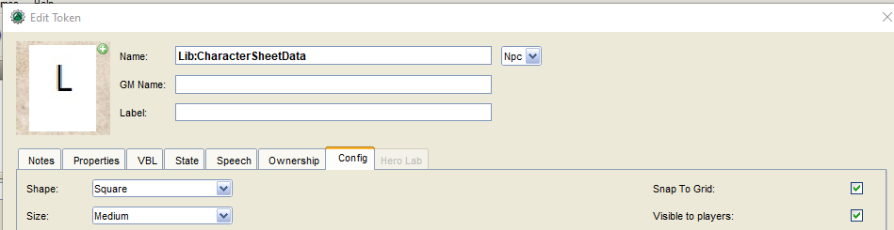

# Recommended Optional Additions To This Framework

## MapTool Help, Add Default Tables

In MapTool using the Help menu, click on "Add Default Tables":

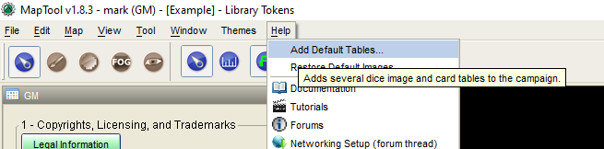

This will add image tables for all the dice, which this framework will then use automatically. If while playing, you try to use a type of die that is not in the image tables, then numbers will be used instead of dice images.

## lib:frames

Down load **lib_frames.rptok** and **frames_table.mttable** [here](https://forums.rptools.net/viewtopic.php?f=8&t=26147&sid=9c0467fbbd5ef6d4f16ff7fb160040cf).

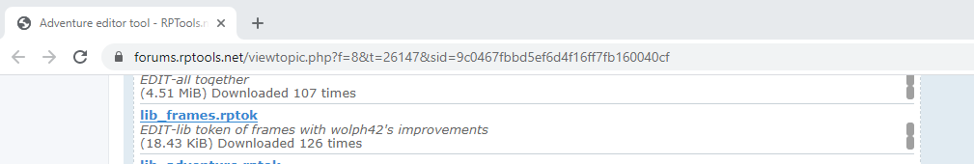

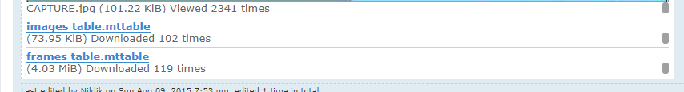

If this is installed along with its associated image table, this framework will use it automatically -- but be sure to setup **both** or you will get an error. I recommend putting it on the same map as the library tokens for this framework. When you do it right, it will look like this:

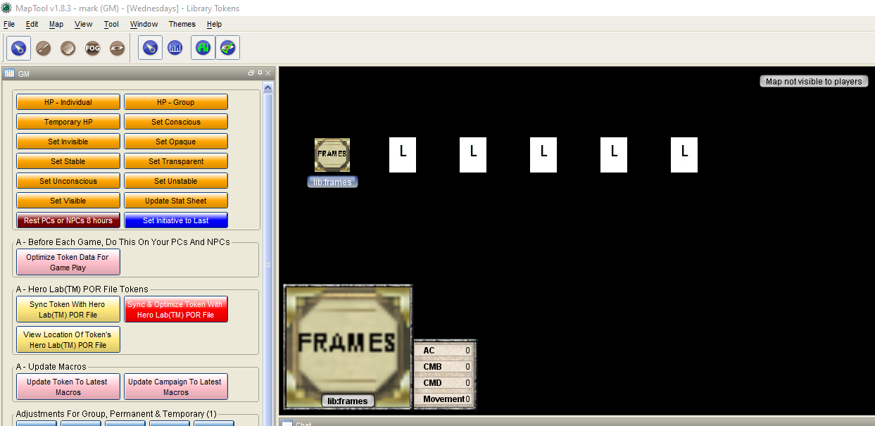

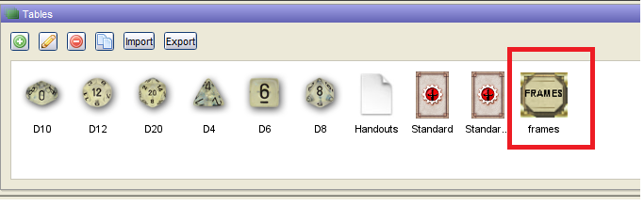

Adding this feature will greatly improve the appearance of the forms created by this framework.

However, forms are often cached for the tokens to save time, so if you add this to your campaign after playing for a while or optimizing your tokens:

Select your tokens and use the **"Clear Cache" macro** on the bottom of the **GM window**. This will **cause the forms used by the tokens to be rebuilt using lib:frames**.

An example of a form used with lib:frames:

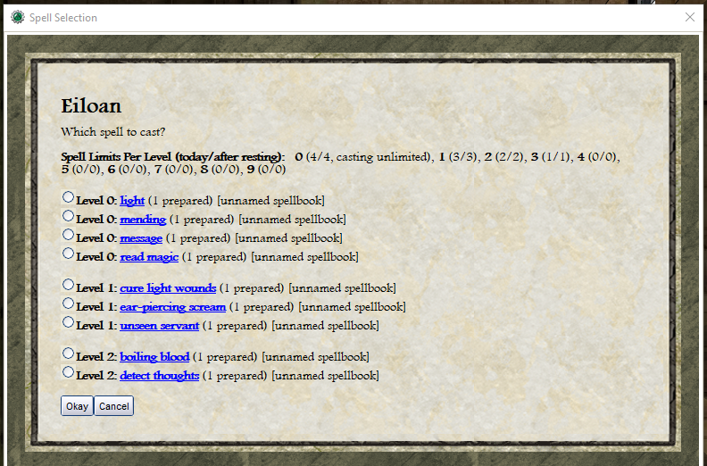

An example die roll with the dice images:

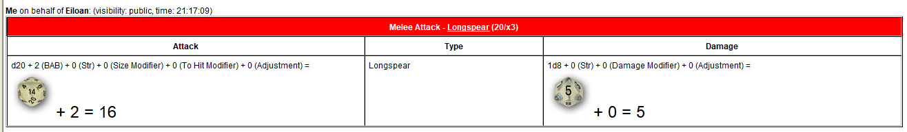

# Upgrading To Newer Version Of My Framework

When upgrading to a newer version of my framework, you’ll need to save the following from the new versions Example.cmpgn file:

* Campaign Settings
* Lib:Utilities
* Lib:CharacterSheet

## Upgrading Campaign Settings

Normally, what you would do is Export the Campaign Settings from the new Example.cmpgn file. Then, Import those Campaign Settings into your current *.cmpgn file (that you’re using for your campaign).

It’s all really cool how this works because your data is preserved. Effectively, you’ll just get the new properties that were defined by the newest Campaign Settings file.

There’s an awkward problem, though. When saving Campaign Settings, that also saves the Tables (see the Tables window). When you Import the new Campaign Settings file, that will replace all the Tables you have.

Therefore, you want to use the following steps to upgrade to the latest Campaign Settings:

1. Backup your latest *.cmpgn file – in case something goes wrong.
2. From your latest *.cmpgn file (for your campaign), export all of the tables in the Tables window – and save them somewhere.
3. From the latest Example.cmpgn file, export Campaign Settings to a file.
4. Into your latest *.cmpgn file, import the latest Campaign Settings from the file.
5. Go to the Tables window and delete all the tables – then import all the tables you exported earlier (this is especially important for the Handouts table!).

## Upgrading The Library Tokens

1. From the latest Example.cmpgn file, save the tokens Lib:Utilities and Lib:CharacterSheet (they are on the Library Tokens map).
2. Replace the old Lib:Utilities and Lib:CharacterSheet tokens with the new ones.
3. Don’t touch the other tokens (including library tokens).

## How The Upgrade Process Works

When you execute macros on your character tokens from the Campaign window or from the GM window, those macros will do a check to see if any upgrades to your tokens are needed. If so, an upgrade will be performed automatically for those tokens.

# Settings To Use To Start The MapTool Server

These are settings I recommend – and recommend using better passwords that people can type easily.

The “Players Receive Campaign Macros” is required for this framework:

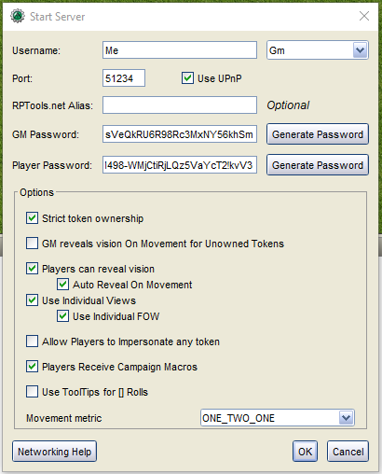

# Hero Lab® Import And Synchronization

This framework enables GMs to import characters from Hero Lab® into this framework – a big time saver!

After the initial import, these characters can be changed in Hero Lab® and re-synchronized with this framework. Basically, what the framework does is remember what the Hero Lab® file looked like last time, preserve the changes you’ve made to your character within this framework in MapTool, and import changes made to the Hero Lab® file. This feature isn’t perfect, but it goes a long way to managing PCs (player characters) for players that like to use Hero Lab® -- or you, the GM, if you like to maintain your NPCs (non-player characters) there, too.

## How To Do The Initial Hero Lab® Import

The process goes like this:

1. Use the “Add Resource to Library” feature of MapTool to add Hero Lab® POR files to your Resource Library.
2. From the Hero Lab® POR file, drag a token onto a map.
3. Use the GM macro “Sync Token With Hero Lab® POR File” to import the data into this framework.

## Add Resource to Library

Use this feature of MapTool:

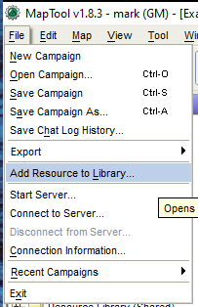

Once successful, your Resource Library will look something like this:

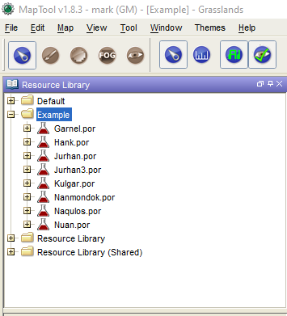

## Drag Hero Lab® POR File Token To Map

Using the bottom part of the Resource Library window, drag a token to one of your maps (note: Kulgar does not have an image but if he did, you would see his token image below instead of an “X”):

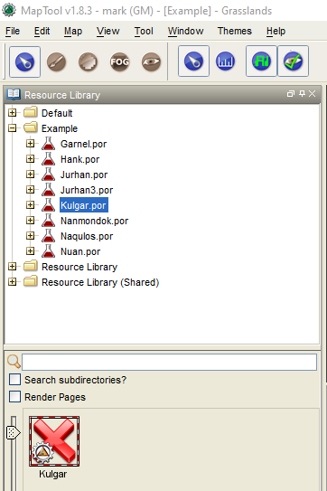

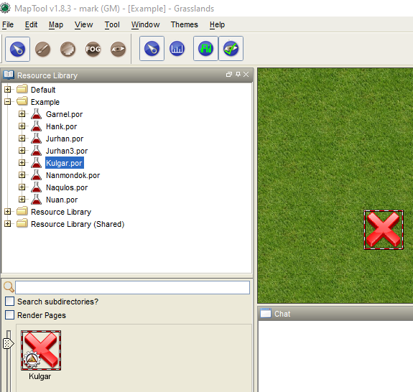

## Run GM Macro “Sync Token With Hero Lab® POR File”

The GM macro **“Sync Token With Hero Lab® POR File”** is the fastest way to import a huge number of tokens all at once if you just want to get it done. I’m not clear exactly how long it takes per token because I no longer do it this way (see ***Consider Doing It All In One Step With “Sync & Optimize Token With Hero Lab® POR File”***).

However, tokens imported this way will not be optimized. Their macros initially will tend to run a little slower. You can drag them onto your maps and use the GM macro **“Optimize Token Data For Game Play”** to optimize only those tokens you plan to use – but more on that later below.

With the token selected, you can run the GM macro **“Sync Token With Hero Lab® POR File”**:

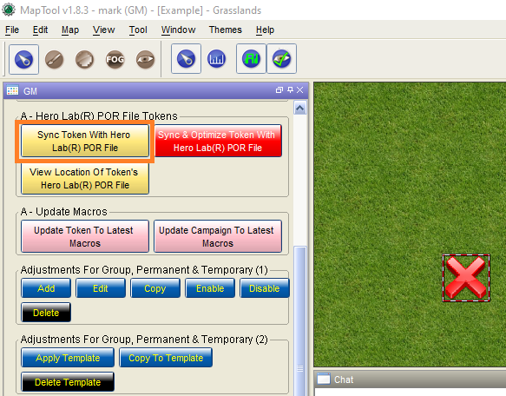

You will, then, see the following dialog:

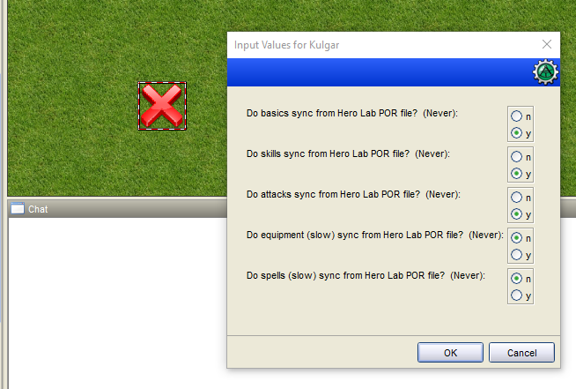

If you are a GM importing NPCs on-the-fly for an encounter, you might just want to import the first three items: basics, skills, and attacks – because importing equipment and spells takes a bit longer but with the performance improvements of MapTool 1.8.3 and higher even these import fairly quickly.

The “(Never)” means you’ve never imported that item before for this token.

Most of the time, importing an NPC takes a minute or so. This character is a bit complex – it’s a PC I used to play in a game and he’s 8th level – so doing the whole import for him takes a while.

So, for this example, I choose the following:

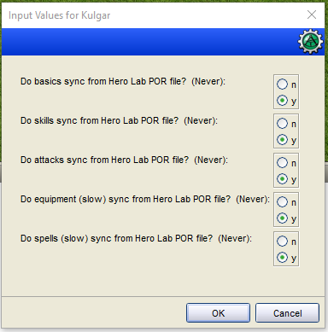

And the Chat window shows:

|  |  |  |  |  |  |  |  |  |  |  |  |  |  |  |  |  |  |  |  |  |  |  |  |  |  |  |  |  |  |  |
| --- | --- | --- | --- | --- | --- | --- | --- | --- | --- | --- | --- | --- | --- | --- | --- | --- | --- | --- | --- | --- | --- | --- | --- | --- | --- | --- | --- | --- | --- | --- |
| **Me** on behalf of **Kulgar**: (visibility: GM, time: 16:02:49) ***Starting*** *synchronizing token 'Kulgar' at 2021-03-11 16:02:49 with Hero Lab POR file:* ***E:\RPG\Example\Kulgar.por***  **Me** on behalf of **Kulgar**: (visibility: GM and self, time: 16:02:51) *Updating token to latest macros ...*  **Me** on behalf of **Kulgar**: (visibility: GM and self, time: 16:02:51) *Updating token to macros supporting base64.encode() to protect data from potential user input errors ...*  **Me** on behalf of **Kulgar**: (visibility: GM and self, time: 16:02:52) *Updated token macro version. Due to the use of base64.encode(), the minimum recommended MapTool version for this token is MapTool 1.5.2.*  **Me** on behalf of **Kulgar**: (visibility: GM and self, time: 16:02:52) *Updated token buffs & conditions to now be controlled through Adjustments ...*  **Me** on behalf of **Kulgar**: (visibility: GM and self, time: 16:02:58) *Updated token 'Kulgar' to latest macro version.*  **Me** on behalf of **Kulgar**: (visibility: GM, time: 16:03:05) ***Imported From Hero Lab: Basics*** *for token 'Kulgar' successfully imported at 2021-03-11 16:03:05 from Hero Lab POR file:* ***E:\RPG\Example\Kulgar.por***  **Me** on behalf of **Kulgar**: (visibility: GM, time: 16:03:19) ***Imported From Hero Lab: Skills*** *for token 'Kulgar' successfully imported at 2021-03-11 16:03:19 from Hero Lab POR file:* ***E:\RPG\Example\Kulgar.por***  **Me** on behalf of **Kulgar**: (visibility: GM, time: 16:03:20) ***Imported From Hero Lab: Attacks*** *for token 'Kulgar' successfully imported at 2021-03-11 16:03:20 from Hero Lab POR file:* ***E:\RPG\Example\Kulgar.por***  **Me** on behalf of **Kulgar**: (visibility: GM, time: 16:03:36) ***Imported From Hero Lab: Equipment*** *for token 'Kulgar' successfully imported at 2021-03-11 16:03:36 from Hero Lab POR file:* ***E:\RPG\Example\Kulgar.por***  **Me** on behalf of **Kulgar**: (visibility: GM and self, time: 16:04:21)  Spell Status: Kulgar   |  |  |  |  |  | | --- | --- | --- | --- | --- | | **Level** | **Topic** | **Status** | **Comment or Issue** | **Maximum Limit or Suggested Action** | | 0 | Today's Spells | **Problem** | Spells are using 6 slots | Your limit is 5! | | 0 | Spells After Resting | **Problem** | After resting, your spells would be using 6 slots | Your limit is 5! |   **Me** on behalf of **Kulgar**: (visibility: GM, time: 16:04:21) ***Imported From Hero Lab: Spells*** *for token 'Kulgar' successfully imported at 2021-03-11 16:04:21 from Hero Lab POR file:* ***E:\RPG\Example\Kulgar.por***  **Me** on behalf of **Kulgar**: (visibility: GM and self, time: 16:04:22)  Spell Status: Kulgar   |  |  |  |  |  | | --- | --- | --- | --- | --- | | **Level** | **Topic** | **Status** | **Comment or Issue** | **Maximum Limit or Suggested Action** | | 0 | Today's Spells | **Problem** | Spells are using 6 slots | Your limit is 5! | | 0 | Spells After Resting | **Problem** | After resting, your spells would be using 6 slots | Your limit is 5! |   **Me** on behalf of **Kulgar**: (visibility: GM, time: 16:04:22) ***Imported From Hero Lab: Spell Limits*** *for token 'Kulgar' checked at 2021-03-11 16:04:22 from Hero Lab POR file:* ***E:\RPG\Example\Kulgar.por***  **Me** on behalf of **Kulgar**: (visibility: GM, time: 16:04:23) ***Done*** *synchronizing token 'Kulgar' at 2021-03-11 16:04:23 with Hero Lab POR file:* ***E:\RPG\Example\Kulgar.por*** |

That’s it! This token is now ready to play with!

## GM Macro “Optimize Token Data For Game Play”

Select your tokens on your map and click this button:

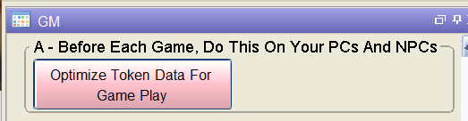

This will make the macros run faster for your tokens. I know what I said above. Normally, I do not run this before each game. You can, if you want. After the performance improvements for MTScript macros in MapTool 1.8.x, I find that even my slowest macros for tokens run with very good performance.

## Consider Doing It All In One Step With “Sync & Optimize Token With Hero Lab® POR File”

Instead of using **“Sync Token With Hero Lab® POR File”**, I recommend running **“Sync & Optimize Token With Hero Lab® POR File”**, instead, because your tokens’ macros will run faster on game day. What this does in reality is run the **“Sync Token With Hero Lab® POR File”** and **“Optimize Token Data For Game Play”** macros for each token. This is what I normally do.

It typically takes about 1 minute per token – so I recommend selecting a group of tokens, clicking the macro below, and walking away. Look at the Chat window for status. When the whole thing is done, it will tell you how it all went and how much time it took. I don’t typically have any problems, so normally you do not need to look at these messages in detail.

Click the following to do it all at once:  
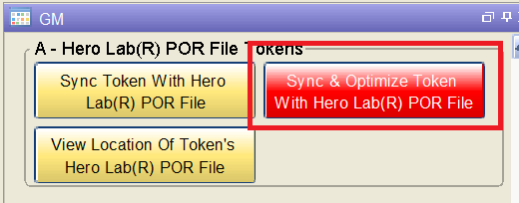

## Synchronize Token With Hero Lab® POR File

Make sure the edited Hero Lab® POR file is in the same location as when you imported the file. If you’ve forgotten, click the GM macro “View Location Of Token’s Hero Lab® POR File”:

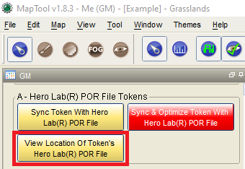

You’ll see the following:

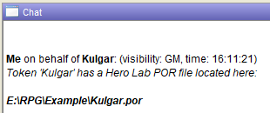

Then, there’s only one thing you need to do here.

Just click the GM macro “Sync Token With Hero Lab® POR File”.



You’ll see messages in the Chat window – just like before – and that’s it!

## Do A Bunch Of Tokens At Once

All you have to do is select multiple tokens that use Hero Lab® and repeat the above steps.

This enables you to walk away and come back from a long import of multiple tokens! It typically takes about 1 minute per token.

## What’s Not Done Yet

Importing feats, traits, drawbacks, tricks, deeds, special abilities, special attacks, and special qualities from Hero Lab® is not done yet. Because most of the players I play with don’t have Hero Lab®, I’ve been using this feature with NPCs. As a GM, I found that this feature was not urgent – but now I have a player I’ve been playing with for a long time that has made a major investment in Hero Lab®. You can bet this feature is coming soon!

# Overview Of Important Features And Concepts

## Token Ownership

Generally, players can only affect their own tokens. The only exception is that a player can give the token belonging to another player equipment items – like a torch.

GMs can affect any token.

## Stat Sheet

When you mouseover a token, its stat sheet will be displayed as appropriate depending on whether you are the owner, GM, or another player. Here’s what I see for a token as the GM:  
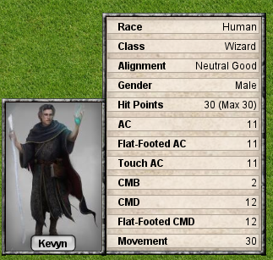

The contents of this stat sheet change automatically as appropriate. New fields appear when needed and others disappear when they are no longer needed.

## Campaign Window

This window is used mainly to interact with the selected token’s character sheet.

### Color Coded Buttons

The buttons for the macros for this window are color coded and have high contrast colors to work better for visually impaired players.

Near the top of the window are macros (buttons) you would use most frequently during game play.

Closer to the bottom of the window are macros (buttons) you would use to edit the character sheet.

Here’s an example. To do a melee attack, you’d select the token making the melee attack and press this button near the top of the window:

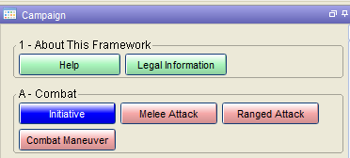

To add more types of melee attacks, you’d select the token and click the “Add” button below – and notice the color of these buttons match (with “Delete” and “View & Delete Links” an exception):

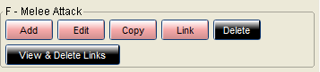

### “Copy” Buttons

“Copy” buttons exist in several places to enable you to copy something and, then, use the “Edit” button to make minor changes.

For melee attacks (see above), it’s common to have different kinds of attacks using, for example, the same weapon.

Say, for example, the character sometimes has a spell cast upon them that increases their size. You might want to have one type of melee attack for when the character is their normal size – and another for when they are enlarged.

### “Give Item” Button

This button is used for a selected token to give an item to another selected token. You select both tokens. When you click the “Give Item” button, you will be prompted to indicate which token is giving the item.

### “Change Elevation” Button

This button enables you to set the elevation (in feet or whatever unit you want) of the selected token. If the elevation is non-zero, it will be displayed under the token. This helps you keep track of characters that are flying or levitating.

Negative numbers might be used for characters that are below ground or swimming, but I can’t remember if that’s supported.

“Display Special Conditions” Button

Special conditions are things that affect a character in certain circumstances. When you edit different parts of the character sheet, you will often be given the opportunity to describe special conditions.

“Only Seen By You” Groups Of Buttons

The idea behind these was to allow players to review their characters without causing an entry to be logged in the Chat window.

When it’s their turn, though, they should use the other buttons so that a Chat window entry will be logged and you have a record of what happened during your game.

“Any” Dice Button

After selecting a token and clicking “Any”, this button brings up a dialog that looks as follows:

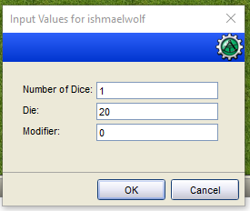

You can specify any type of die, even something like “3” (for a “d3”).

### “Campaign” Buttons



The following buttons display campaign information for players (and GMs). These buttons display information in a player view. No GM information is displayed.

#### “Handouts” Button

The “Handouts” button requires a token to be selected and displays only those handouts relevant to that token.

### “Log” Buttons

These buttons display the relevant information for the selected token. The purpose of these buttons is to display the audit log for the selected token in whatever context is appropriate.

The audit log helps players and GMs keep track of when certain actions or events important to a token occurred – and this feature has been very useful in quickly settling arguments (such as, for example, a player who swears they never casted that spell and should be able to cast it now).

This feature is very useful when a single day in game time lasts for multiple game sessions in real world time.

### “Adjustments, Permanent & Temporary” Buttons

Adjustments are those things you do to a character because they’ve picked up a condition, had a spell cast on them, used a light source, had ability damage or drain, get a bonus to a skill, etc.

Adjustments are applied automatically to a character when relevant and enabled.

For example, a character that has suffered strength damage will have an adjustment applied automatically to their melee attack rolls – unless some other ability is the ability they use for attacks due to a feat, class feature, or something.

This is a very powerful feature. It can also help you keep track of when adjustments expire. The stat sheet will show these adjustments (if you want).

#### “Apply Template” Button

Adjustment “templates” are supported. So, you can setup templates for conditions, light sources, and spells in advance and simply apply them to selected tokens as needed:

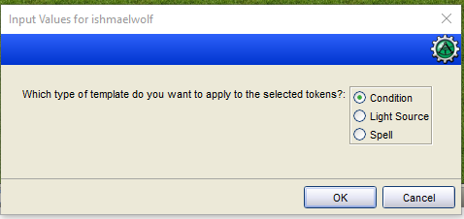

### “Edit Spells Prepared” Button

This feature is for prepared spell casters. It brings up a dialog that looks like this:

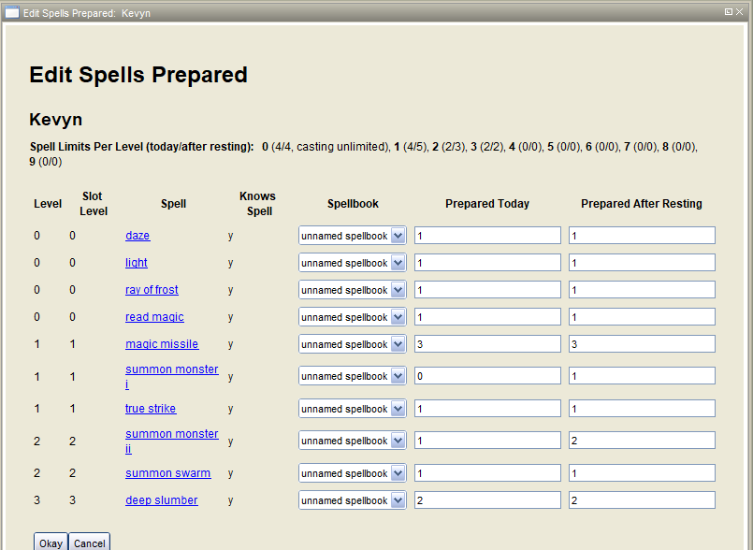

Some important notes about this view:

* Spells can be organized into spellbooks (more on this later).
* We can track whether or not a spell is known to the caster (more on this later).
* “Prepared After Resting” allows players to define the spells to be prepared after resting at any time – so there’s no more delay after the GM rests the party. This is a feature I haven’t found in other VTTs.

### “Validate Spell Limits” Button

After entering a tokens spells-per-day limits in “Edit Spells Per Day” and, for prepared spell casters, setting up the prepared spells in “Edit Spells Prepared”, this button can be used to produce a report to look for any problems.

Players won’t be prevented from casting spells – but each time they do any problems will be reported.

### “Set Item Locations” Button

This feature enables players and GMs to easily move equipment items around and place them in slots on the character or in containers the character carries.

### “Rollup” Button

This feature is used to consolidate all the money a character has by the type of coin.

Be careful. This cannot be reversed.

For example, if a character has some gold pieces in a backpack and some in a belt pouch, clicking this button will consolidate all of it into one place.

## GM Window

This window is used to manage the campaign, do some in-game things, and do some maintenance activities on the tokens.

### Macros

#### Copyrights, Licensing, and Trademarks

Please leave the following button in with the information I created there. I’ve put a lot of work into this framework and I’d like to have credit.

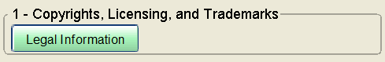

#### General Token Management

This section currently looks as follows:

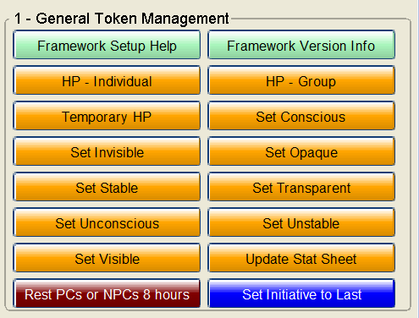

##### HP – Individual

1. Use this by selecting a token and clicking the button. The following dialog pops up:
2. 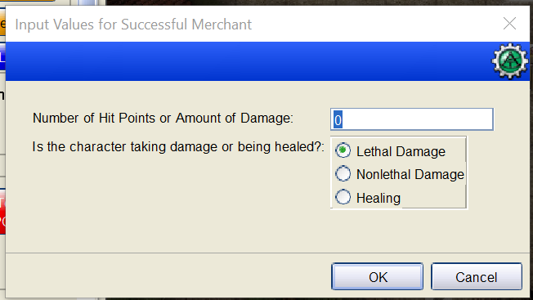
3. Enter a numeric value in the textbox above for “Number of Hit Points or Amount of Damage”.
4. Choose one of the radio buttons for what to use that for.
5. Click “OK”.

If you have multiple tokens selected, then one of these dialogs will pop up for each token – but that’s tedious so see “HP – Group”.

##### HP – Group

This macro (button) is very similar to “HP – Individual”, except that when you have a group of tokens selected, only one dialog pops up for the whole group and is applied to each token in the group.

##### Temporary HP

Use this macro to update the temporary hit points a token has:

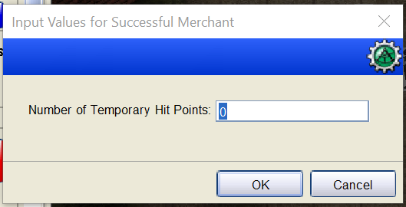

This dialog pops up with the temporary hit points the token currently has and you can update it. This token currently has 0 temporary hit points.

##### Set Conscious, Set Stable, Set Unconscious

These macros are convenient ways to set the current state of the selected tokens: conscious, stable, or unconscious.

##### Set Invisible, Set Opaque, Set Transparent, Set Visible

“Set Invisible” is the opposite of “Set Visible”, while “Set Opaque” is the opposite of “Set Transparent”.

“Set Invisible” ensures that players can’t see the token and makes it transparent to remind the GM it is invisible.

“Set Transparent” makes a token transparent but the players can still see it.

##### Update Stat Sheet

If you use the “Edit Token” dialog (such as by double-clicking on the token) and change the states by checking or unchecking the checkboxes – you need to click this macro (button) to update the state sheet for the token.

##### Rest PCs or NPCs 8 Hours

Select tokens, click this macro (button), and a many things are restored due to 8 hours rest: damage healed, nonlethal damage healed, energy pools, things with per day uses, spells, and adjustments with non-permanent durations are disabled.

##### Set Initiative to Last

Select tokens, put them into initiative if they aren’t already, click this macro (button), and they will all be set to the last initiative rolled for them. This is useful if you hop over to a new map – or just screw up somehow.

#### Optimize Tokens (so they run faster)

Here, I’ll discuss the following macro (buttons) that are used to make tokens run faster (optimize them): Optimize Token Data For Game Play, Update Token To Latest Macros, and Update Campaign To Latest Macros.

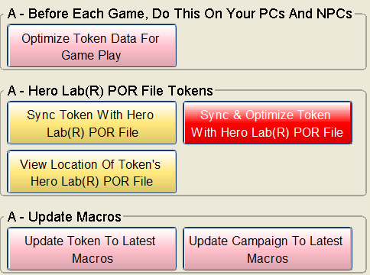

##### Optimize Token Data For Game Play

Some HTML forms are generated the first time you run various macros (buttons) for a token. For the tokens you have selected, this macro will generate all the HTML forms up-front to make them run faster during game day.

##### Update Token To Latest Macros

When the library tokens for this framework are updated to a newer version, when a macro (button) is clicked for a token, that token is automatically updated to work with the newer macros in the updated framework. Select multiple tokens and click this button to do that all at once for those tokens to save yourself some time during game day.

##### Update Campaign To Latest Macros

This macro (button) is similar to the “Optimize Token Data For Game Play” macro (button), except that it generates generalized HTML forms used by the campaign rather than individual tokens. Therefore, you do not need to select a token to run this macro.

#### Hero Lab® POR File Import

These macros are described elsewhere in this document:

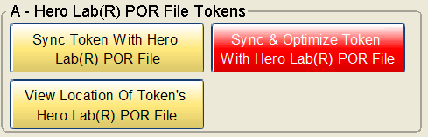

#### Adjustments

Adjustments are pretty much templates you apply to tokens for many reasons such as being poisoned, having a spell cast on them, having a condition, having a buff, effects from a magic item, drink a potion, become a light source, etc.

They encompass the following:

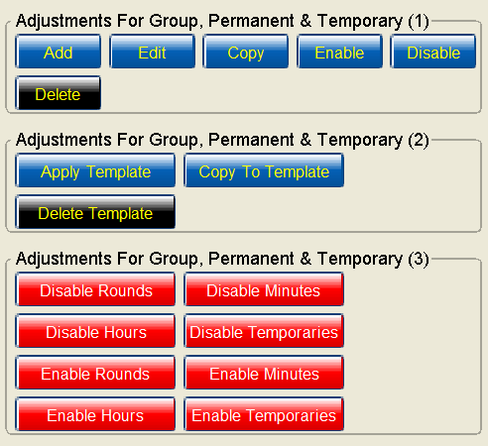

##### Copy

This macro (button) can be used to copy and adjustment from one token to another token.

##### Apply Template

This macro (button) is used to apply an adjustment you’ve previously saved as a template via “Copy To Template”. To use it, you just select the token or tokens you want to apply the adjustment to and click this macro (button). A dialog such as the following will popup:

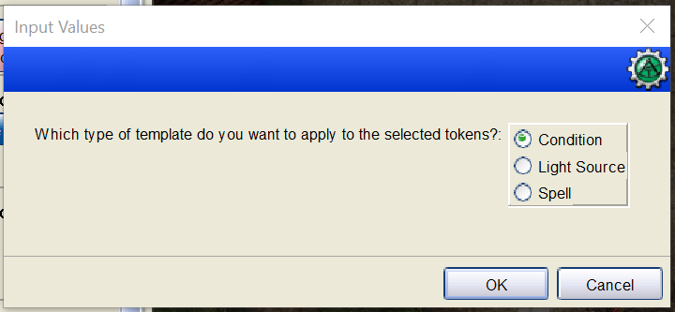

##### Copy To Template

See “Apply Template” above.

Disable Rounds, Disable Minutes, Disable Hours, and Disable Temporaries

Select tokens and use one of these macros (buttons) to disable adjustments already applied to these tokens that have a duration of rounds, minutes, or hours. In the case of “Disable Temporaries”, adjustments with rounds, minutes, and hours will be disabled.

(More to come.)